Query the list of CITY names from **STATION** which have vowels (i.e., a, e, i, o, and u) as both their first and last characters. Your result cannot contain duplicates.

**Input Format**

The **STATION** table is described as follows:

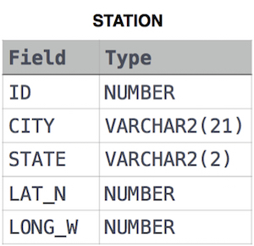

where LAT_N is the northern latitude and LONG_W is the western longitude.